1. Enable the ON_SUCCESS event on the CONFIRM_DRAFT_ORDER TRANSACTION

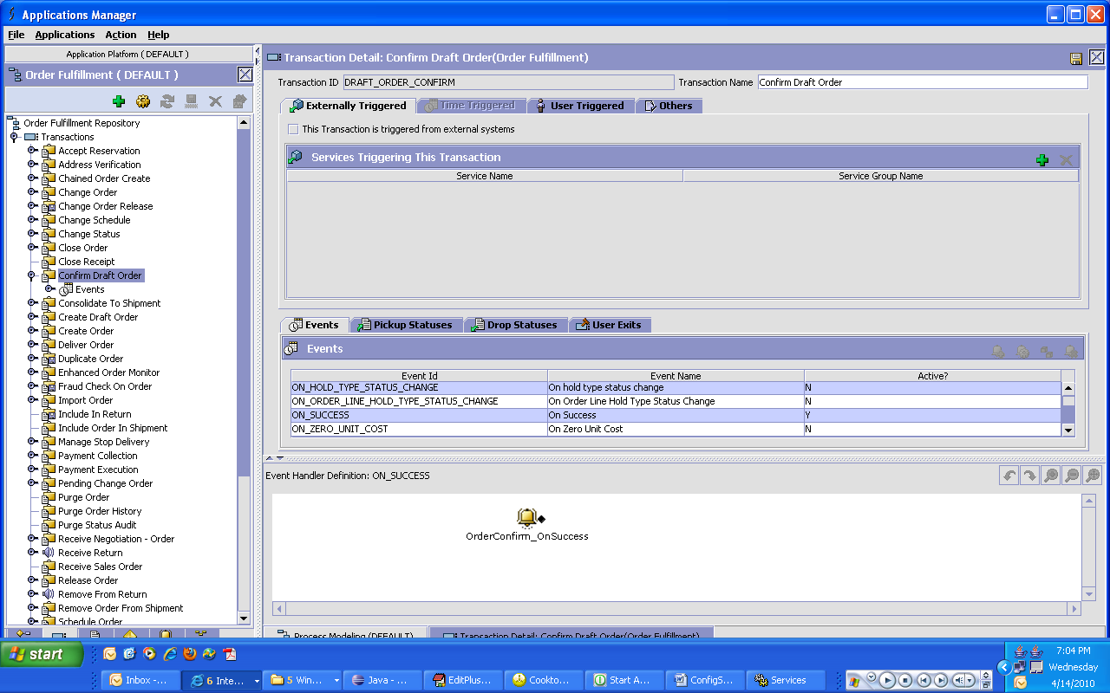

1. The Aevent handler has an Action configured which will be as follows:

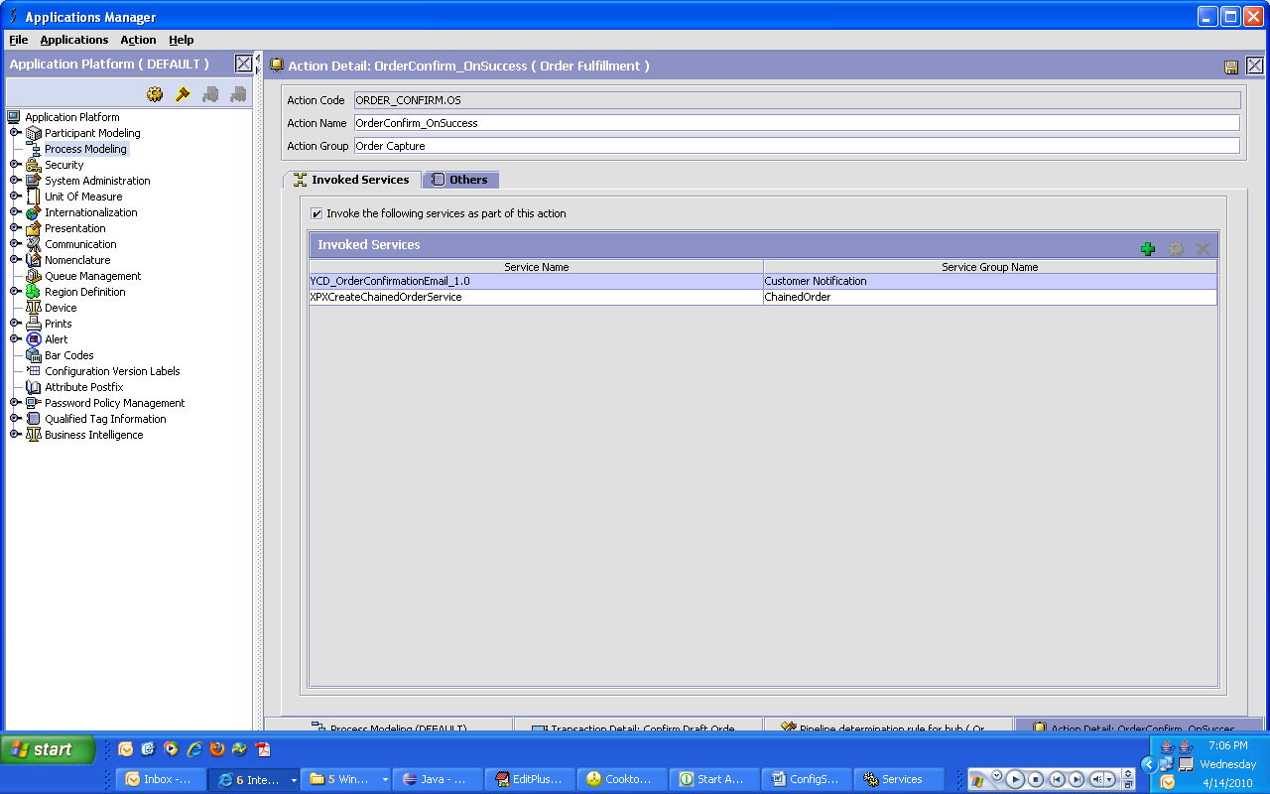

1. Below given are the steps for creating the XPXCreateChainedOrderService which is service invoked as part of the above action to create the chained orders:

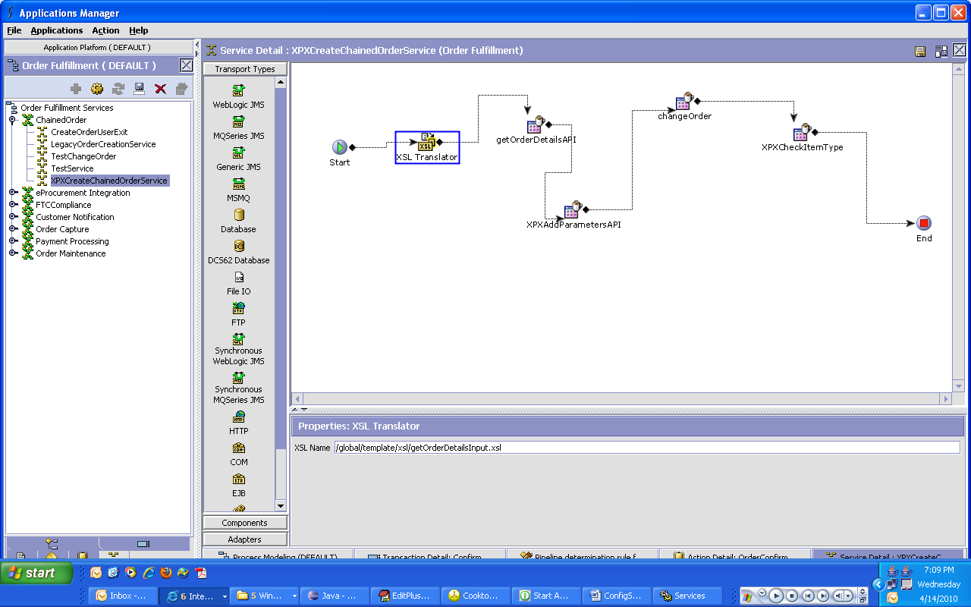

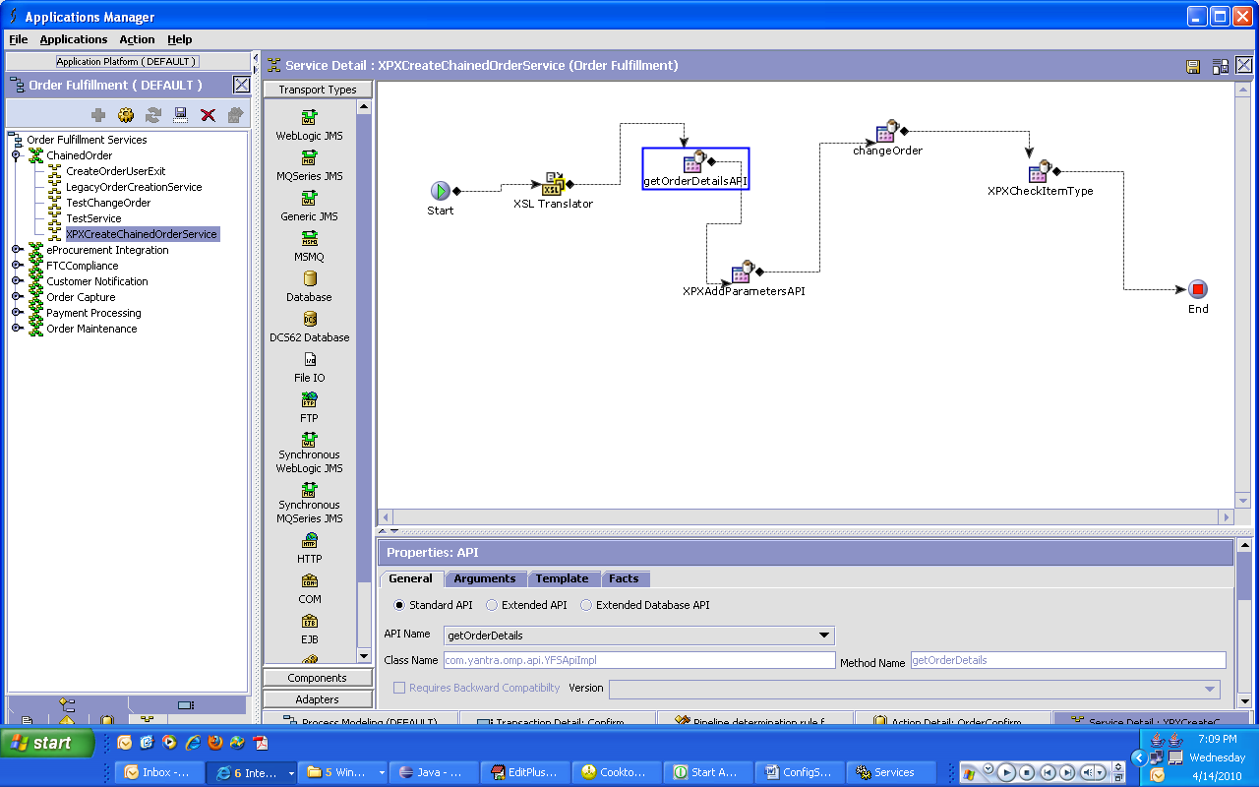

The output xml for getOrderDetails can eithe rbe configured in this way or can be extended using the overriden getOrderDetails input template.

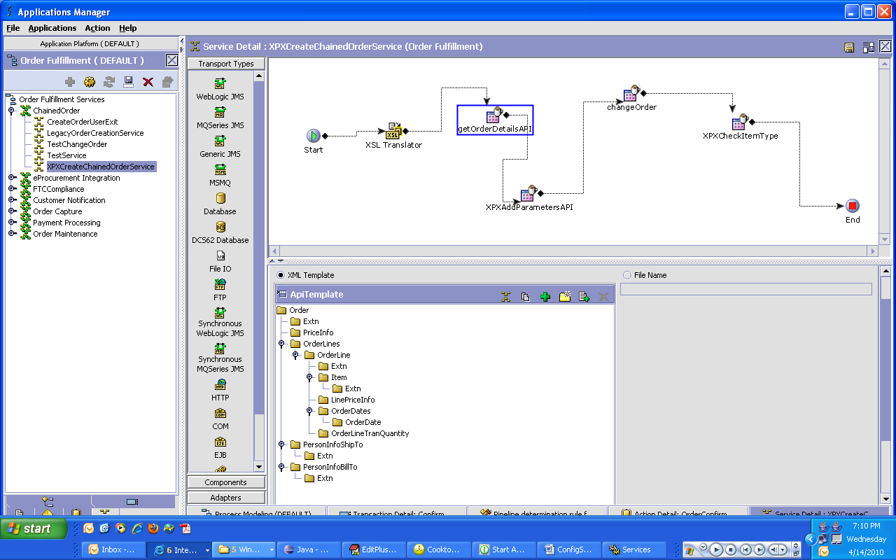

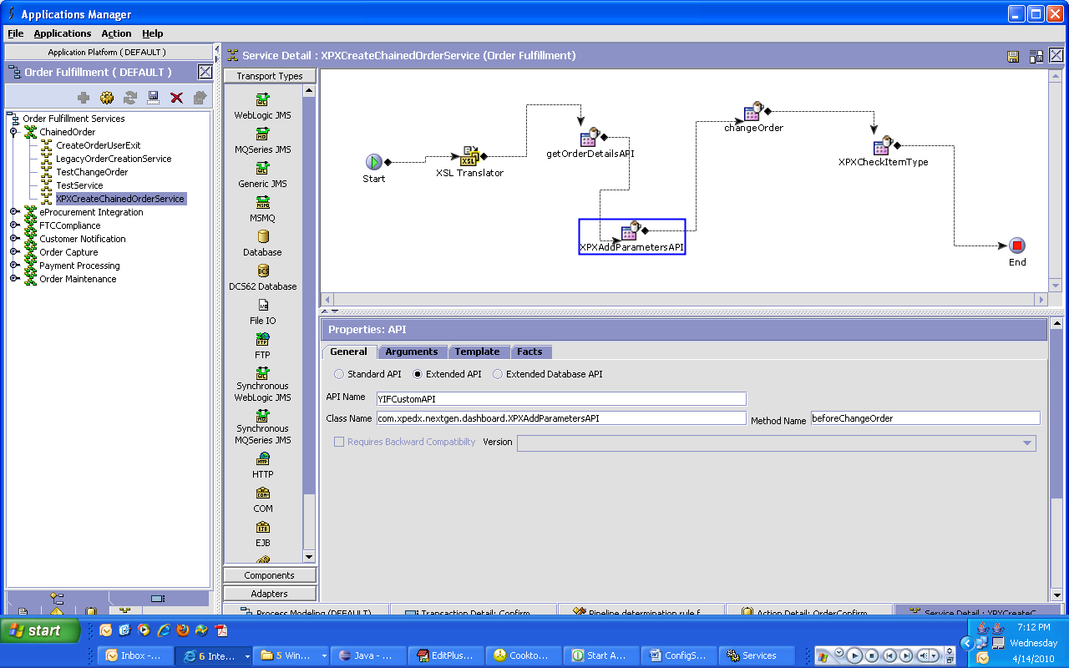

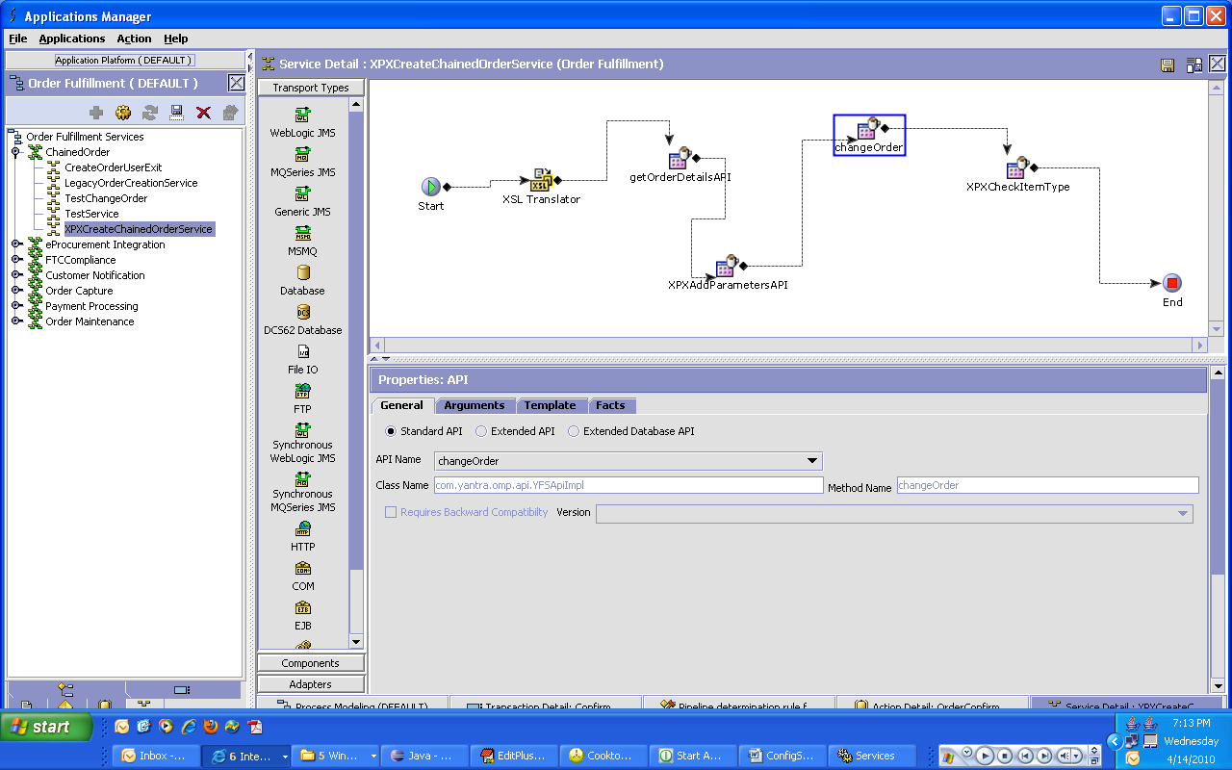

The changeOrder output template can be overriden in the way given below or by extending the default ORDER_CHANGE.ON_SUCCESS template

